The Analysis of Returned Orders: Understanding the Root Causes

Story 1: A summary of the analysis of returns

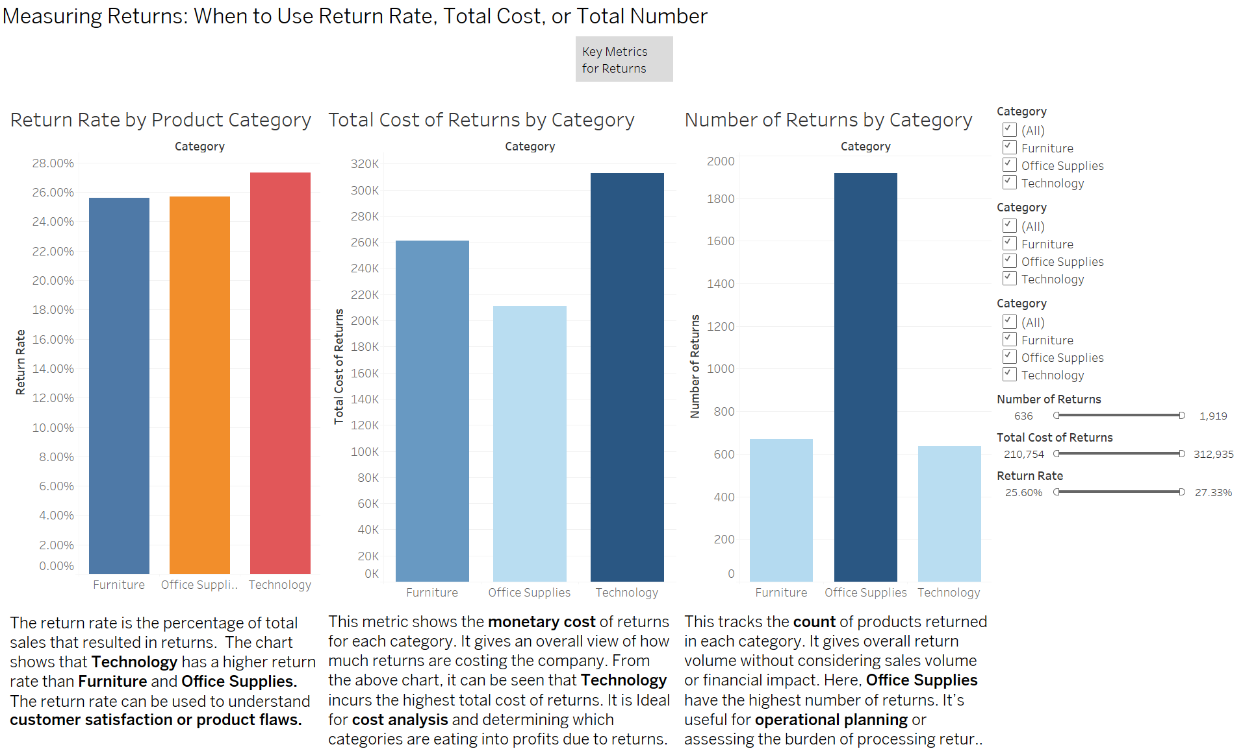

The above image explains when to use different return metrics such as return rate, total cost of returns, and total number of returns:

1. **Return Rate by Product Category**: shows the percentage of total sales that resulted in returns. Technology has the highest return rate, indicating potential product quality issues or dissatisfaction. This metric helps assess **customer satisfaction and product reliability.**
2. **Total Cost of Returns by Category**: highlights the financial impact of returns. Technology incurs the highest cost, making this metric useful for cost analysis and understanding the profit impact of returns.
3. **Number of Returns by Category**: Focuses on the total count of returned items. Office Supplies lead in return volume, which helps in operational planning and understanding the logistical burden of handling returns.

Story 2: Key Root Causes of Returns

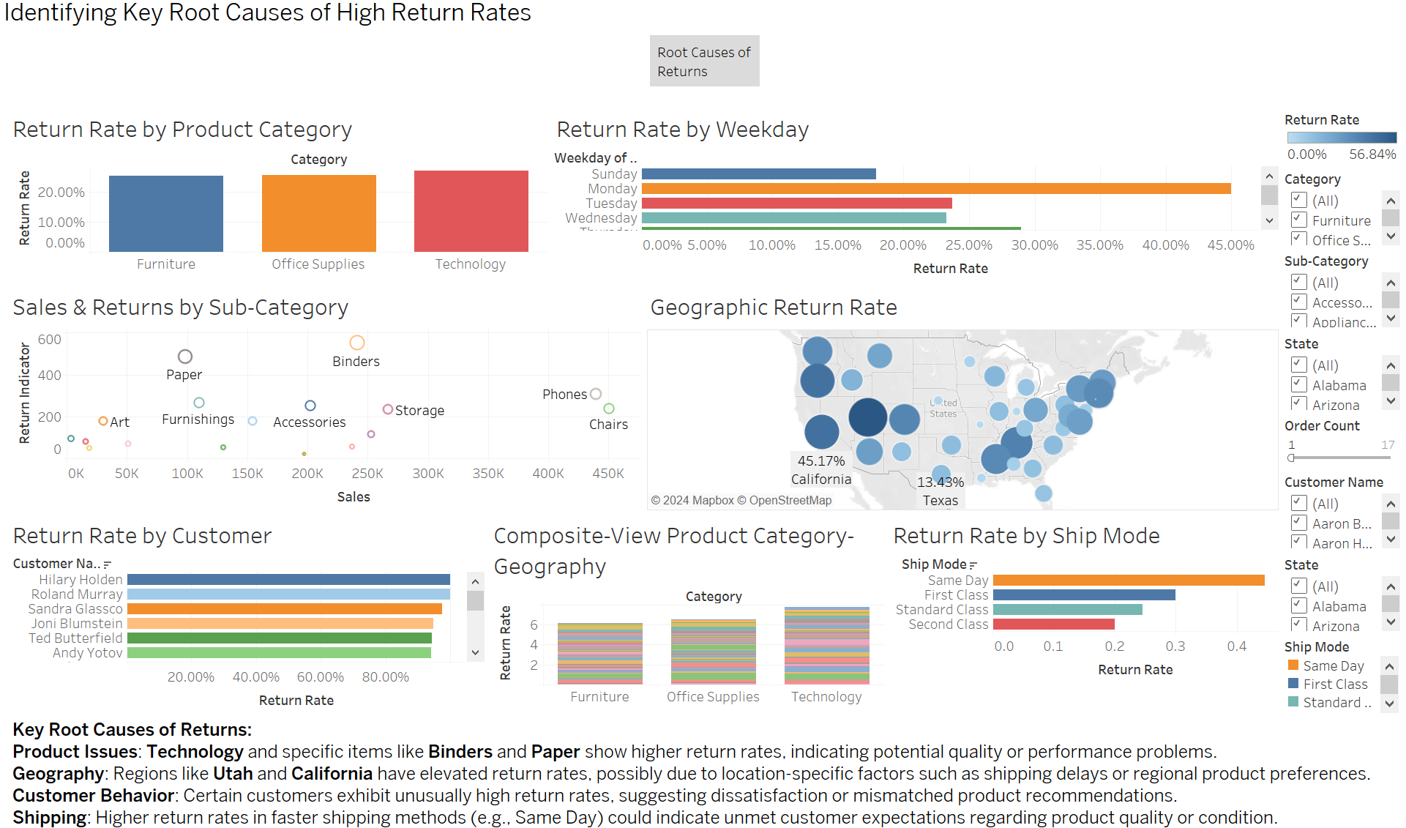

This dashboard identifies key root causes of high return rates:

1. **Product Issues**: Technology, and specific items like **Binders** and **Paper**, show higher return rates, indicating quality concerns.
2. **Geography**: **Utah** and **California** have elevated return rates, likely influenced by shipping or regional preferences.
3. **Customer Behavior**: Certain customers exhibit unusually high return rates, suggesting dissatisfaction or mismatched products.
4. **Shipping**: Faster shipping methods (e.g., **Same Day**) show higher return rates, potentially due to unmet product expectations.
5. **Weekday Returns**: The high return rate on **Monday** maybe because customers often receive packages during the week and spend the weekend deciding if they want to keep or return items, leading to a surge of returns on Monday.

Story 3: Understanding the Elements of the Dashboard

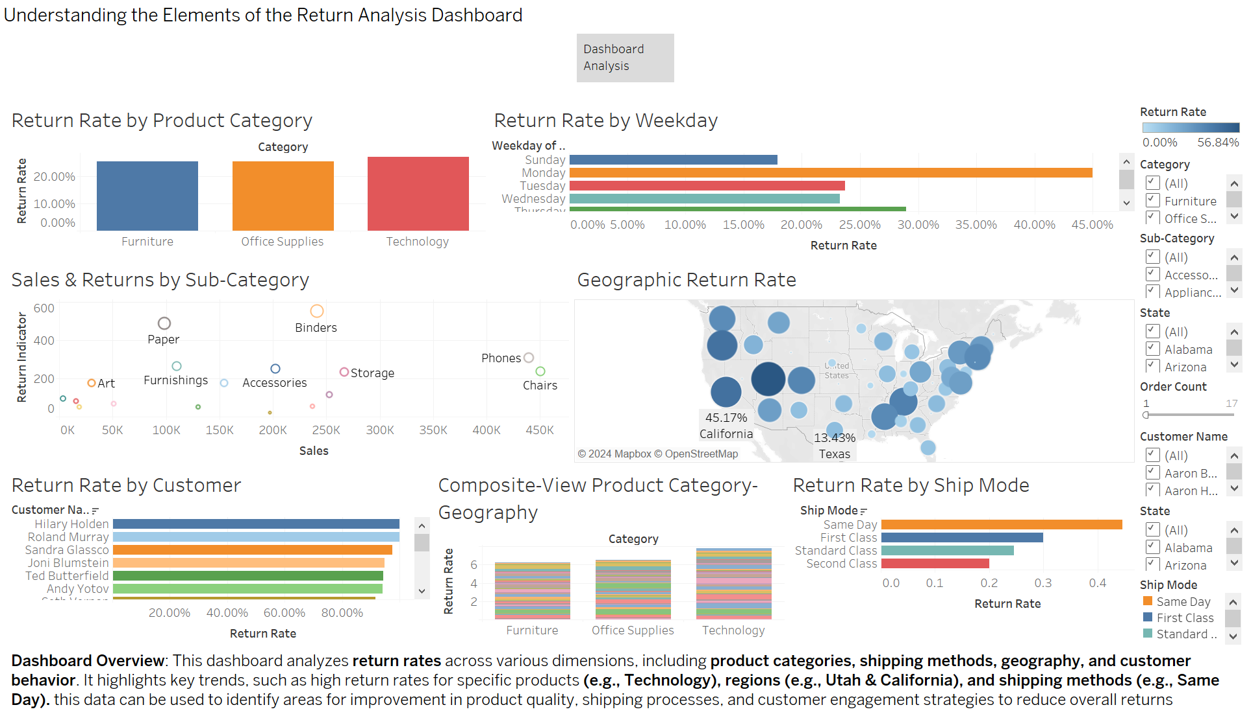

This dashboard analyzes return rates across various dimensions such as product categories, shipping methods, geography, and customer behavior. It highlights key trends, including high return rates for **Technology**, certain regions like **Utah** and **California**, and faster shipping methods like **Same Day**. This data helps identify areas for improving product quality, shipping processes, and customer satisfaction to reduce overall returns.

Story 4: Using the Dashboard to Identify Root Causes with Filters

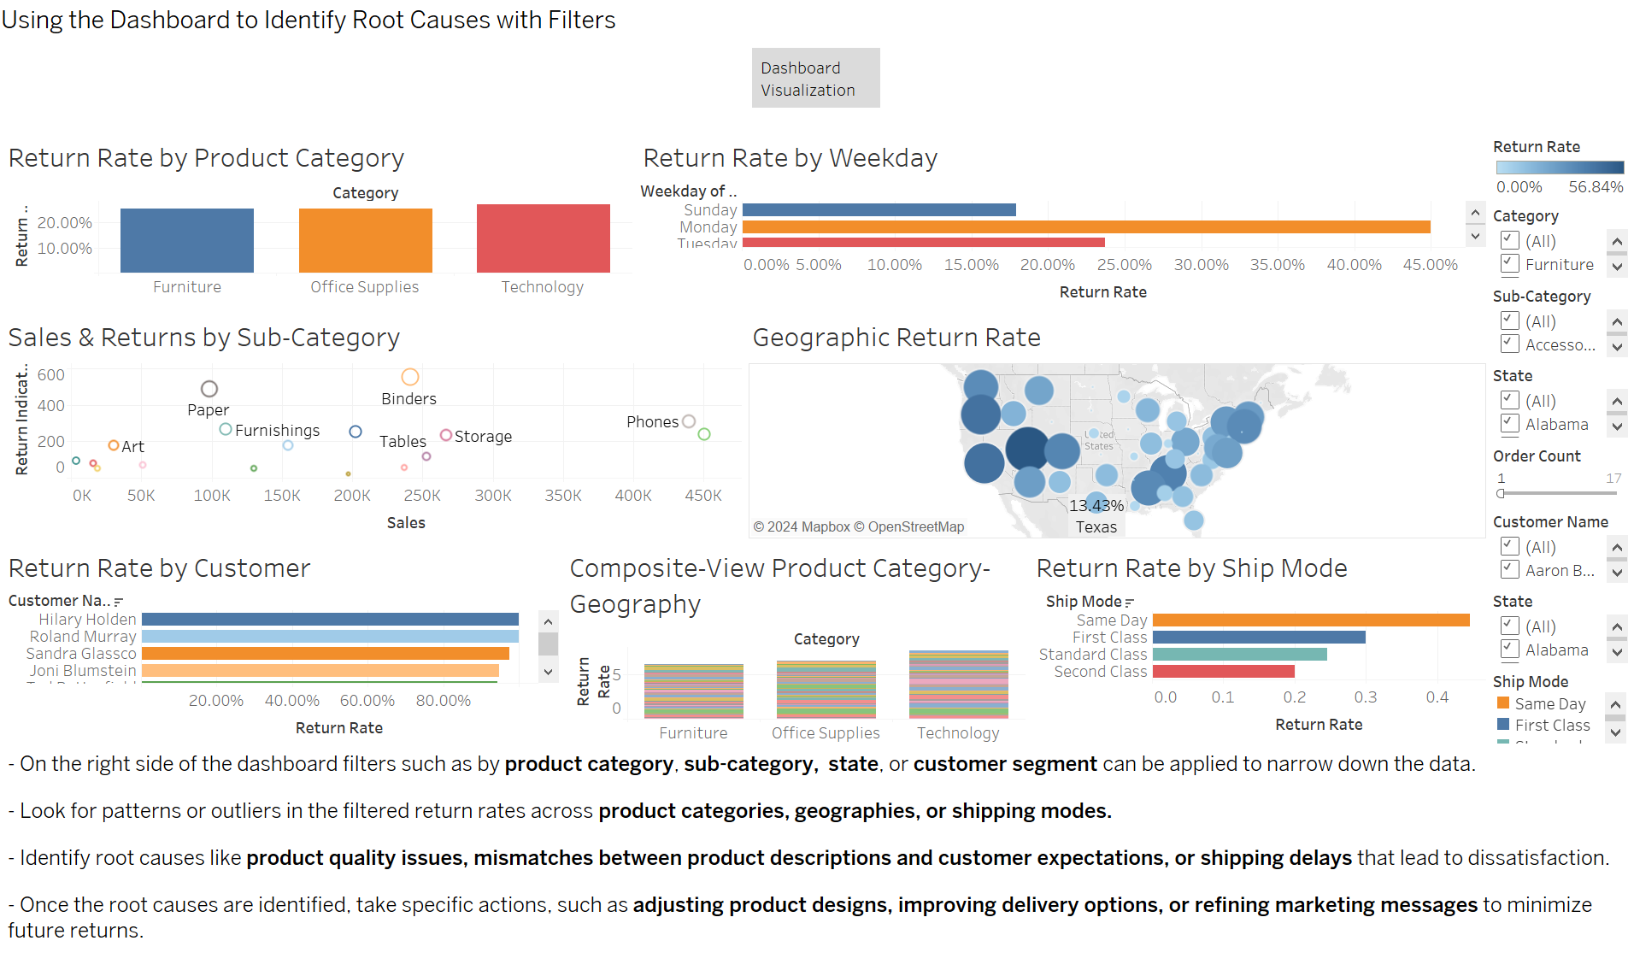

By applying filters such as **product category, sub-category, state, or customer segmen**t, the dashboard helps uncover patterns in return rates across categories, geographies, and shipping modes. These insights allow identifying key root causes, such as product quality issues, misaligned product descriptions, or shipping delays. Once these causes are identified, specific actions such as adjusting product designs, improving delivery logistics, or refining marketing messages can be implemented to reduce returns and enhance customer satisfaction.

Story 5: A conclusion with proposed next steps

High return rates are driven by issues in the technology category, especially binders and paper, which suggest quality problems. Certain regions, like Utah and California, show elevated return rates, possibly due to shipping delays or local preferences. A few customers, like Hilary Holden, have unusually high return rates, indicating dissatisfaction or product mismatch. Same-day shipping is associated with higher returns, suggesting unmet customer expectations. Addressing these areas can reduce return rates and improve customer satisfaction.

Proposed Next Steps:

2. Review product quality for Technology items (Binders, Paper).

3. Investigate high-return customers (e.g., Hilary Holden) and offer personalized solutions.

4. Analyze regional preferences and shipping issues in California and Utah.

5. Optimize same-day shipping to align with customer expectations.

6. Use dashboard filters (e.g., by product, region, and customer) to perform detailed analysis and take real-time data-driven actions.